Case study: Multi-provincial outbreak investigation of E. coli O157:H7 associated with frozen hamburgers

Final Epidemiologic Summary
September 5, 2014

Summary
- There were 17 laboratory-confirmed cases identified as part of this investigation. (Manitoba=6, Saskatchewan=5, Alberta=4, British Columbia=2). The case ages ranged from 5 to 82, with a median of 30.5; 47% of the cases were female. The illness onset dates ranged from June 28 to July 19, 2014.
- Two brands of frozen burgers manufactured at one facility were recalled August 3, 2014 by the Canadian Food Inspection Agency.
- The outbreak was declared over on Sep 2, 2014. No additional cases were identified after the recall.

Background

The outbreak was first identified nationally on July 21, 2014 when the National Enteric Surveillance Program reported an increase in E. coli O157 cases nationally, as well as in Saskatchewan and Manitoba. Subsequently, a cluster of six cases of E. coli O157:H7 with matching PFGE patterns was reported by PulseNet Canada. Prior to this, on July 18, 2014, Saskatchewan identified a cluster associated with a Canada Day BBQ; this cluster was subsequently linked with the national investigation.

Epidemiological Summary

Case definitions
Confirmed case: A resident or visitor to Canada with
- Laboratory confirmation of E. coli O157:H7 AND
- PFGE pattern combination ECXAI.1398/ECBNI.1212 OR ECXAI.1398/ECBNI.2985 AND
- Symptom onset or laboratory confirmation on or after June 1, 2014

Probable case: A resident or visitor to Canada with
- Laboratory confirmation of E. coli O157:H7 AND
- PFGE pending AND
- Symptom onset or laboratory confirmation on or after June 1, 2014

Suspect case: A resident or visitor to Canada with
- Symptoms* consistent with E. coli O157:H7 infection AND
- An epidemiological link to a confirmed case AND
- Symptom onset on or after June 1, 2014

*Diarrhea (three or more loose stools within 24 hours)

Laboratory Summary
There were 17 laboratory-confirmed cases identified as part of this investigation. Sixteen cases had the PFGE pattern combination ECXAI.1398/ECBNI.1212 while one case had ECXAI.1398/ECBNI.2985. Eleven cases had MLVA subtyping performed; all eleven cases had matching MLVA patterns. There were no probable cases at the time the outbreak was declared over.

Descriptive Epidemiology
The 17 cases were identified in 4 provinces (Manitoba=6, Saskatchewan=5, Alberta=4, British Columbia=2). The case ages ranged from 5 to 82, with a median of 30.5; 47% of the cases were female. The illness onset dates ranged from June 28 to July 19, 2014.

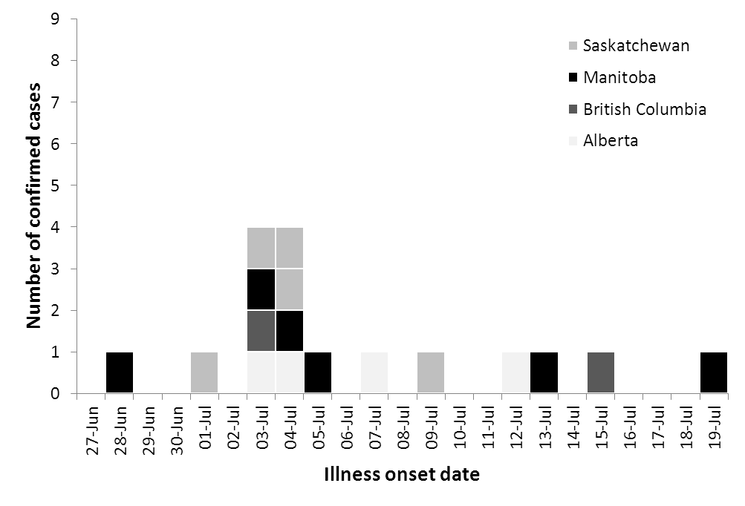
Figure 1: Number of confirmed outbreak cases of E. coli 0157:H7 by illness onset date (n=17).

Exposures
Of the 17 confirmed cases, seven were interviewed with a hypothesis-generating questionnaire, six were interviewed with a focused questionnaire, one case was interviewed with both questionnaires, and three cases were lost to follow-up.

Of the eight cases that were interviewed with the hypothesis-generating questionnaire, seven reported eating hamburgers but five could not remember the brand. One case did not report hamburger exposure.

All seven cases that were interviewed with the focused questionnaire reported exposure to the frozen hamburgers. Of those, 6/7 could recall the brand of the products they ate, and all (6/6) reported consuming either Farmer Fred’s Burgers or Happy Burger frozen hamburgers.

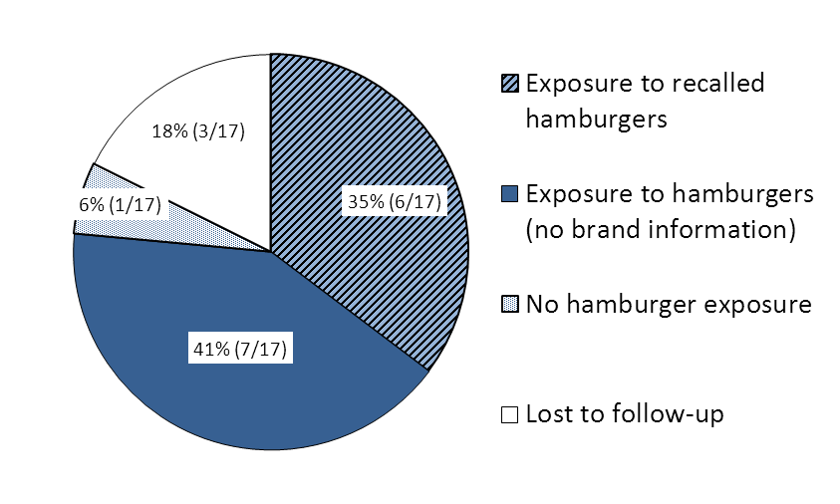
Figure 2: Summary of case exposures.

Food Safety Investigation
Traceback conducted by the Canadian Food Inspection Agency (CFIA) identified that the two brands of burgers reported by interviewed cases, Happy Burger and Farmer Fred’s Burgers, were produced at the same facility in the same time frame. The facility is located in Alberta and produces two other brands of burgers in addition to the recalled brand. A recall was issued on August 3, 2014, for all burgers produced on June 2 to June 8, 2014 at the facility. This included two lot of Farmer Fred’s Burgers and one lot code of Happy Burger.
CFIA began an inspection of the facility on August 1, which included the collection of product and environmental samples. The facility inspection did not reveal any items of concern.

Food samples
Samples were collected from the homes of two cases. One was an open box of Happy Burger, the other was an open box of Farmer Fred’s Burgers. Both tested positive for the presence of E. coli O157:H7. The PFGE pattern of these samples matches the outbreak strain.
CFIA obtained 40 samples from the facility and retail: 8 samples from the recalled lots, 20 samples from the lots produced on previous and subsequent dates (as well as brands produced at the facility but not included in the recall), and 12 environmental samples. Four samples from the recalled lots (unopened boxes of product) tested positive for E. coli O157:H7, with all four PFGE patterns matching the outbreak strain. E. coli was not detected in the samples from the previous and subsequent lots of burgers, or from the environmental samples.

Conclusion

The likely sources of illnesses in this outbreak were two different brands on frozen hamburgers produced at the same facility: two lots of Farmer Fred’s Burgers and one lot of Happy Burger. These products were effectively recalled, however, it is possible that additional cases associated with this exposure will be reported, due to the long shelf life of these products.

