Case study: [2020-060] Multi-provincial outbreak of Salmonella Newport
Cluster Code: 2005NEWWGS-1ON-MP
Final Investigation Summary
 | Confirmed cases (n=18)
P/T Case Count | QC = 2  ON = 7  AB = 3  BC = 6
Estimated Burden of Illness | 470
Age (years)  Mean  Median  Range | 31.5  26.5  17-57
Sex: % Female | 83% (15/18)
Hospitalizations | 0
Deaths | 0
Best Date Range | April 22, 2020 (Onset date) to  May 19, 2020 (Onset date)
Reporting Delay (days)  Range  90th Percentile | 17-24  24
Epidemic Curve | Confirmed cases by best available date (n=18)  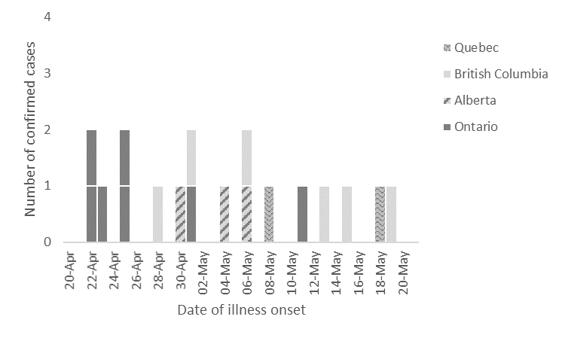

Initial Stages of the Investigation
- The outbreak was first identified on May 8, 2020 when the National Enteric Surveillance Program (NESP) reported an increase in Salmonella Newport cases in Ontario. Five Ontario isolates were found to be genetically related by whole genome sequencing (WGS). Ontario began investigating these cases.
- Subsequently, NESP reported an increase in Salmonella Newport cases on May 15, 2020 nationally, as well as in British Columbia, Alberta and Ontario.
- On May 21, 2020, the National Microbiology Laboratory (NML) posted a WGS cluster of nine Salmonella Newport cases (ON=6, AB=1, BC=2) to the Canadian Laboratory Surveillance Network (CLSN) discussion board on the Canadian Network for Public Health Intelligence (CNPHI) with PulseNet Canada (PNC) cluster code 2005NEWWGS-1ON-MP.
- An OICC Assessment Call was held on May 25, 2020, and partners agreed to activate a national OICC.
Epidemiologic Investigation
- Exposure information was received for 15/18 cases (Hypothesis generating questionnaire=8, focused questionnaire=7, routine provincial questionnaire=11)
  - 7 cases were re-interviewed by PHAC-OMD using a focused questionnaire (ON= 2, AB=1,BC=4 )
  - 3/18 cases were lost to follow up (ON=1, AB=1, QC=1)
- The following foods were reported in higher than expected frequencies during re-interviews (See Appendix B), but no commonalties were observed in brand, purchase locations or supplier information:
  - 6/12 cases reported flax seeds
  - 6/12 cases reported sesame seeds
  - 6/14 cases reported blueberries
  - 7/12 cases reported almonds
  - 5/12 cases reported walnuts
- Chia Seeds
  - 12/14 cases reported chia seeds
  - 3 cases reported purchasing “Smile” brand chia seeds
    - 1 purchased at Healthy Lifestyle Emporium Store A
  - 1 case reported purchasing “Nature’s Planet” brand chia seeds
- 8 cases did not have brand information available
  - 1 purchased at Healthy Lifestyle Emporium Store B
  - 1 purchased at a local independent grocery store
  - 2 cases had “Smile” brand chia seeds were confirmed via purchase records

Laboratory Investigation
- All confirmed cases were considered related by 0-6 wgMLST (see Appendix C).
- The outbreak cluster was within 0-25 alleles of a historic cluster of four Ontario cases from 2019 (1908NEWWGS-1ON). The onset dates for this cluster ranged from August 8, 2019 to September 2, 2019. The source of this outbreak was never confirmed, although some type of nut or seed product was suspected.
- There no non-clinical isolates within 25 alleles of the outbreak cluster in the PulseNet Canada database and no US matches to the outbreak cluster were identified.

Food Safety Investigation
- The Canadian Food Inspection Agency (CFIA) conducted traceback on the baby spinach consumed by the three Ontario cases and one BC case. The spinach eaten by the Ontario cases was traced back to two distributors. Both distributors obtain spinach from a hydroponic greenhouse located in the province and only distribute product within Ontario. This greenhouse provides product to only these two distributors. As the spinach is not distributed outside of Ontario and the other cases are not reporting travel to Ontario, it is unlikely that the spinach is the source of the outbreak. Traceback on the spinach consumed by the BC case found that the store they purchased spinach from sources their produce from a farm that only distributes produce in Western Canada, so no further traceback was conducted. Because of the lack of commonalties between the spinach the sources consumed, spinach has been ruled out as a likely source of these illnesses.
- Traceback conducted by CFIA identified that the two brands of chia seeds reported by cases and identified on case purchase records, “Smile” brand and “Nature’s Planet” brand, were packaged at the same facility in the same time frame. The facility is located in Ontario. No other brands or products are packaged at this facility. CFIA began an inspection of the facility on June 5, which included the collection of product and environmental samples. The facility inspection did not reveal any items of concern.
- Samples were collected from the homes of two cases on June 5. One was a closed package of “Smile” brand chia seeds, the other was an open package of “Nature’s Planet” brand chia seeds. The lot code on the closed package matched the lot code on the package of chia seeds consumed by the case. Both tested positive for the presence of Salmonella on June 11. The samples were found to be genetically related by WGS to the outbreak strain on June 18.
- CFIA obtained 40 samples from the facility and retail: 8 samples from the recalled lots, 20 samples from the lots packaged on previous and subsequent dates and 12 environmental samples. Four samples from the recalled lots (unopened packages of product) tested positive for Salmonella on June 12, with all four samples found to be genetically related by WGS to the outbreak strain on June 19. Salmonella was not detected in the samples from the previous and subsequent lots of chia seeds, or from the environmental samples.
- A Health Risk Assessment (HRA) was completed on June 6, 2020 by Health Canada. A Health Risk 2 was assigned for the two different brands of chia seeds: “Smile” brand (two lot codes) and “Nature’s Planet” brand (one lot code), which includes all the products produced at the one facility over April 14-15, 2020.
- CFIA determined that the appropriate risk management action was a Class I recall to the consumer level with a Food Recall Warning. The company agreed to conduct the voluntary recall and a food recall warning was issued on June 6, 2020.

Public Health Communications
- A Public Health Alert (PHA) was posted to CNPHI on May 25, 2020.
- A Public Health Notice (PHN) was posted on the Government of Canada website on June 6, 2020 to advise the public that an outbreak investigation of Salmonella infections was underway, and to identify “Smile” and “Nature’s Planet” brand chia seeds as a source of illnesses. The PHN linked to the CFIA recall notice.
- The PHN was promoted through the Healthy Canadians social media channels and shared by PHAC’s social media accounts.
- A final PHN was posted on July 8, 2020 informing the public the outbreak was declared over and the investigation had been closed.

Final Stages of the Investigation
- Based on the epidemiologic, microbiological and food safety investigation, exposure to “Smile” brand and “Nature’s Planet” brand chia seeds was identified as a likely source of the outbreak. The root cause of contamination was not identified.
- The outbreak was declared over and the OICC de-activated on June 7th, 2020.
- No additional cases were identified with onset dates after the recall.
- A post-outbreak debrief was not held for this investigation.

Appendix A: Case Definition
Confirmed case:
A resident of or visitor to Canada with:
- Laboratory confirmation of Salmonella Newport AND
- Isolate matching PulseNet Canada cluster 2005NEWWGS-1ON-MP by whole genome sequencing* AND
- Symptom onset or laboratory confirmation on or after April 1, 2020
*Guidelines for whole genome sequencing interpretation are determined by the Public Health Agency of Canada (PHAC)’s National Microbiology Laboratory.

Appendix B – Food exposure frequencies of confirmed cases compared to Foodbook Canada reference values (n=7).

Food Item | Confirmed Cases |  |  |  |  | Reference | Binomial Probability
 | Yes | Prob | No | DK | %Y+P | Foodbook Canada* | p-value
MEATS
Any chicken (not including deli meat) | 3 | 0 | 3 | 1 | 50.0 | 85.6 | 0.0375
Any pork (not including deli meat) | 1 | 2 | 3 | 1 | 50.0 | 55.1 | 0.3028
Any beef (not including deli meat) | 1 | 1 | 4 | 1 | 33.3 | 78.4 | 0.0201
EGGS
Any eggs | 2 | 3 | 2 | 0 | 71.4 | 80.7 | 0.2677
DAIRY PRODUCTS
Any dairy (excluding cheese) | 3 | 1 | 3 | 0 | 57.1 | 84.6 | 0.0655
Non-dairy milk | 3 | 0 | 3 | 1 | 50.0 | No data | No data
Any cheese | 4 | 0 | 3 | 0 | 57.1 | 88.8 | 0.00306
VEGETABLES
Tomatoes | 3 | 1 | 3 | 0 | 57.1 | 72.9 | 0.1967
Any lettuce or leafy greens | 4 | 1 | 1 | 1 | 83.3 | 82.4 | 0.4011
Iceberg | 0 | 2 | 3 | 2 | 40.0 | 41.1 | 0.3452
Romaine | 2 | 1 | 3 | 1 | 50.0 | 48.8 | 0.312
Spinach | 4 | 0 | 1 | 2 | 80.0 | 28.4 | 0.0233
Sprouts | 2 | 1 | 4 | 0 | 42.9 | 12.9 | 0.0432
Cucumbers | 3 | 2 | 2 | 0 | 71.4 | 62.9 | 0.2846
Bell peppers | 4 | 0 | 2 | 1 | 66.7 | 63.6 | 0.3252
Broccoli | 3 | 0 | 3 | 1 | 50.0 | 55.5 | 0.3013
Cauliflower | 4 | 0 | 3 | 0 | 57.1 | 33.0 | 0.1248
Mushrooms | 4 | 0 | 3 | 0 | 57.1 | 50.0 | 0.2734
Zucchini | 3 | 1 | 3 | 0 | 57.1 | 21.1 | 0.0341
FRUITS
Melons | 3 | 0 | 3 | 1 | 50.0 | 39.7 | 0.2744
Apples | 4 | 1 | 2 | 0 | 71.4 | 72.3 | 0.3183
Bananas | 4 | 2 | 1 | 0 | 85.7 | 76.7 | 0.3321
Citrus fruits | 4 | 0 | 3 | 0 | 57.1 | 65.0 | 0.2679
Any berries | 5 | 0 | 2 | 0 | 71.4 | 65.2 | 0.2997
Strawberries | 2 | 2 | 2 | 1 | 66.7 | 49.6 | 0.2306
Raspberries | 2 | 0 | 3 | 2 | 40.0 | 27.5 | 0.2882
Blueberries | 3 | 2 | 2 | 0 | 71.4 | 31.3 | 0.0298
Blackberries | 3 | 1 | 3 | 0 | 57.1 | 10.5 | 0.003
Mangoes | 4 | 0 | 3 | 0 | 57.1 | 15.7 | 0.0127
Pineapple | 1 | 1 | 5 | 0 | 28.6 | 30.0 | 0.3177
NUTS & SEEDS
Peanuts | 4 | 0 | 3 | 0 | 57.1 | 33.6 | 0.1306
Almonds | 2 | 3 | 1 | 1 | 83.3 | 41.0 | 0.041
Walnuts | 3 | 1 | 2 | 1 | 66.7 | 18.5 | 0.0117
Hazelnuts (filberts) | 0 | 0 | 6 | 1 | 0.0 | 10.1 | 0.5279
Cashews | 2 | 0 | 1 | 4 | 66.7 | 26.8 | 0.1577
Pecans | 2 | 1 | 3 | 1 | 50.0 | 12.9 | 0.0284
Pistachios | 0 | 0 | 4 | 3 | 0.0 | No data | No data
Other nuts | 1 | 0 | 3 | 3 | 25.0 | No data | No data
Peanut butter | 4 | 0 | 3 | 0 | 57.1 | 55.0 | 0.2918
Other nut butters/pastes/spreads | 2 | 1 | 3 | 1 | 50.0 | 18.3 | 0.0668
Sunflower seeds | 2 | 1 | 3 | 1 | 50.0 | 18.3 | 0.0668
Sesame seeds | 2 | 2 | 2 | 1 | 66.7 | 17.1 | 0.0088
Chia seeds | 3 | 2 | 2 | 0 | 71.4 | No data | No data
Flax seeds | 2 | 2 | 2 | 1 | 66.7 | No data | No data
Other seeds | 1 | 0 | 3 | 3 | 25.0 | No data | No data
OTHER
Cold cereals | 2 | 0 | 4 | 1 | 33.3 | 54.3 | 0.1929
Hot cereals | 2 | 0 | 2 | 3 | 50.0 | 28.5 | 0.2491
Vegetarian/Vegan | 2 | 0 | 3 | 2 | 40.0 | No data | No data
Supplements | 3 | 0 | 4 | 0 | 42.9 | 28.2 | 0.2086
*Canada. Infectious Disease Prevention and Control Branch. Foodbook Report. Guelph: Public Health Agency of Canada; 2015.

Appendix C: wgMLST Analysis for event 2020-060 (cluster code 2005NEWWGS-1ON-MP )
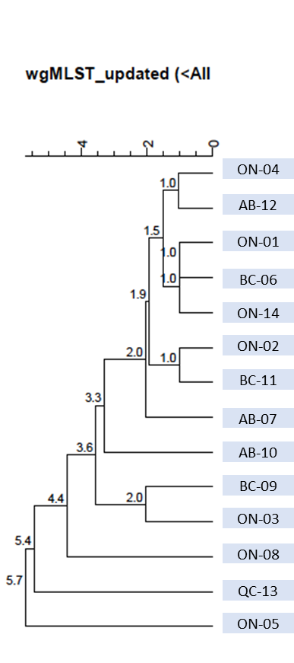
Text description: WGS analysis illustrating genetic relatedness of 14 cases. Cases are all genetically related by 0-5.7 wgMLST allele differences.

Based on multiplier for Salmonella (26.1) obtained from Thomas MK, Murray R, Flockhart L, et al. Estimates of the burden of foodborne illness in Canada for 30 specified pathogens and unspecified agents, Circa 2006. Foodborne Pathog Dis 2013;10(7):639-648.

