Case study: [2020-060] Multi-provincial outbreak of Salmonella Newport
Cluster Code: 2005NEWWGS-1ON-MP
Epidemiologic Update, May 24, 2020 as of 12:00 EDT
 | Confirmed cases (n=9)
P/T Case Count | ON=6  AB=1  BC=2
Estimated Burden of Illness | 235
Age (years)  Mean  Median  Range | 30.4  22  17-57
Sex: % Female | 78% (7/9)
Hospitalizations | 0
Deaths | 0
Onset date range | April 22, 2020 – May 1, 2020
Reporting Delay (days)  Median  Range | 21  19-26
Epidemic curve | S. Newport cases by symptom onset and province (n=9)  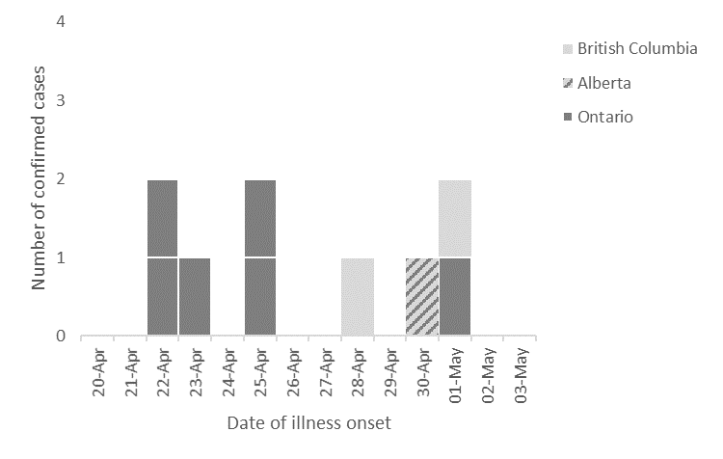

UPDATES
Epidemiological:

- Initial exposure information is available for 7/9 cases (7 questionnaires; ON=5, BC=2)
  - 1 case is lost to follow up (ON=1)
  - 1 questionnaire is pending (AB=1)
Exposure summary
- Baby spinach
  - 4/7 (57%) cases report exposure to baby spinach
- Chicken
  - 2/7 (29%) cases report exposure to chicken
    - 2 cases report purchasing from the same local butcher shop
- Eggs
  - 2/7 (29%) cases report exposure to eggs
- Berries
  - 2/7 (29) cases report exposure to any berries
    - 1 case reports exposure to blueberries
- Nuts
  - 4/7 (57%) cases report exposure to any nuts
- Seeds
  - 4/7 (57%) cases report exposure to any seeds
- Special/restricted diets
  - 3/7 (43%) cases report following a special or restricted diet
    - 1 case reports following a vegetarian diet (no beef, pork, chicken)
    - 1 case reports following a ‘raw food’ and vegan diet
    - 1 case reports an aversion to dairy products

Laboratory:
- All confirmed cases are related by 0-6 wgMLST allele differences.

Based on multiplier for Salmonella (26.1) obtained from Thomas MK, Murray R, Flockhart L, et al. Estimates of the burden of foodborne illness in Canada for 30 specified pathogens and unspecified agents, Circa 2006. Foodborne Pathog Dis 2013;10(7):639-648.

