Newer:
[EVENT ID] Event title
Proposal for declaring the outbreak over
DATE

PHAC-OMD proposes that the outbreak be declared over on [DATE] based on the following rationale:
Criterion 1: The number of outbreak cases being reported to public health authorities has returned to baseline levels.
The expected baseline incidence of cases based on surveillance data prior to the outbreak and as defined by the outbreak case definition is [N].
Criterion 2: The last time that individuals may have been exposed to the implicated source has been identified or estimated.
The last time that individual(s) may have been exposed to the outbreak source is estimated using [LAST EXPOSURE ESTIMATE] (e.g. hazard removal (i.e. restaurant closure, food recall); illness onset; or return to baseline) is [DATE].
Criterion 3: Sufficient time has lapsed for potentially exposed individuals to become ill and be reported to investigating public health authorities.
The maximum incubation period of [PATHOGEN] infection is [X] days and the [XXth] percentile in reporting delay observed in this outbreak is [Y] days.

PHAC proposes to declare the outbreak over after the maximum incubation period ([X] days) and the [XXth] percentile in reporting delay ([Y] days) have elapsed since the last expected exposure on [DATE]. Therefore, if no additional cases are identified the outbreak would be declared over on [OVER DATE].
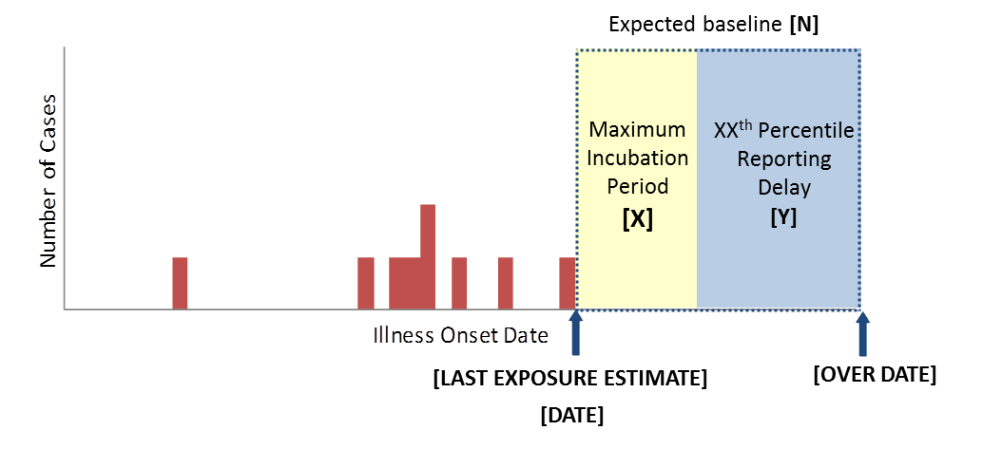
Definitions

N: cases per period of time (e.g. month, year etc.)
LAST EXPOSURE ESTIMATE: last exposure to the outbreak source estimated using date of hazard elimination, most recent illness onset, or return to baseline
DATE: date of last exposure estimate
X: maximum incubation period of the pathogen
Y: XXth percentile reporting delay as observed in the outbreak
OVER DATE: the date the outbreak is declared over based on the three criteria
Older:

[Outbreak title]

Proposal for deactivating the OICC and declaring the outbreak over

The OICC will be deactivated and the outbreak declared over based on the following rationale:

1. Deactivating the OICC
[Lead agency] proposes that the OICC be deactivated on [date]. [Lead agency] will continue to monitor the situation and if new information suggests that there is an on-going risk the proposed timelines will be reassessed and revised as needed. Should the situation warrant it, the OICC can be reopened following discussion with the OICC members.

The OICC deactivation is proposed for the following reasons:

[CONSIDER AND INCLUDE THE FOLLOWING, AS APPROPRIATE]

- As per the FIORP, there is consensus among the OICC members that all avenues of investigation have been exhausted.
- All of the investigation information has been shared and discussed among OICC members.
- The epidemiological investigations for all cases are complete.
- CFIA has indicated that the traceback investigation is complete and there is no additional information expected at this time.

2. Declaring the outbreak over [consider using a figure to illustrate the rationale, rather than or in addition to text]

[Lead agency] proposes that the outbreak be declared over on [date] based on the following rationale:

To determine when the outbreak can be declared over, consider three criteria (1) Identify the expected baseline levels (2) Identify the last time that individuals may have been exposed to the outbreak source, (3) Allow enough time to pass to allow individuals to become ill and be reported to public health authorities.

[PROVIDE ANALYSIS BASED ON ABOVE CRITERIA / ADDITIONAL BULLETS MAY BE REQUIRED]

- Criterion 1: The expected baseline incidence for PFGE pattern [X] is [X cases per period of time (e.g., year, month, etc.). [Describe the period of time for which the number of cases reported has returned to baseline.]
- Criterion 2: The most recent date of illness onset is [date] or The date of product recall, [date], is considered to be the last time individuals may have been exposed to the implicated source.
- Criterion 3: The maximum incubation period of [PATHOGEN] infection is [X] days and the [XXth]* percentile in reporting delay observed in this outbreak is [X] days. [*use the 75th to 100th percentile]
- Calculation: [Criterion 2 date] + [Criterion 3 reporting delay] = [Date to declare the outbreak over]
- Therefore this outbreak can be declared over on [date].

[Insert figure which should include the outbreak epidemic curve, the maximum incubation period, the reporting delay and references to the three criteria. See example on next page]

Example from Case study, Exercise 5: Declaring the outbreak over
* The date the outbreak could be declared over was calculated on day 35 of the outbreak (Thursday, June 11, 2020). Note that this date is not static and needs to be updated if new relevant information comes in (e.g., new traceback information suggests other products/product lots may be contaminated).

